Pathfinding Agent Report
1. Introduction
This project demonstrates a grid-based pathfinding agent implemented in Python using Tkinter for GUI. The agent explores two search strategies: A* and Greedy Best-First Search (GBFS) to find the shortest path between a start and goal node while avoiding obstacles.
The GUI allows users to set:
- Start Node (Green)
- Goal Node (Red)
- Obstacles/Walls (Black)
The performance of each algorithm is measured in terms of:
- Nodes Expanded
- Execution Time (ms)
2. Implementation Logic
2.1 Node Representation
Each cell in the grid is represented by a Node object, which contains:
- row and col – coordinates
- color – current display color
- neighbors – valid adjacent nodes
- g – cost from the start node
- parent – pointer for path reconstruction
2.2 Grid Creation
- Grid of size 20x20 (can be adjusted) is generated using make_grid().
- Each node is initialized as white (walkable).
- User can click to set start, goal, or walls.
2.3 Neighbor Updates
update_neighbors(grid) ensures each node’s neighbors list excludes walls, allowing movement in four directions: up, down, left, right.
2.4 A Algorithm*
Logic:
- Uses g(n) (distance from start) + h(n) (heuristic to goal) to select nodes.
- Heuristic: Manhattan distance: abs(a.row - b.row) + abs(a.col - b.col)
- Nodes are expanded using a priority queue (min-heap) sorted by f = g + h.
- Path is reconstructed from the goal node via parent links.
Steps:
- Initialize start node g = 0.
- Push start node into priority queue.
- Pop node with lowest f from queue.
- If goal reached → reconstruct path.
- Update neighbors if a shorter path is found (temp_g < neighbor.g).
Color Representation:
- Grey: Currently explored node
- Yellow: Neighbor being added to open set
- Blue: Final path
2.5 Greedy Best-First Search (GBFS)
Logic:
- Uses heuristic h(n) only (ignores g(n)).
- Explores nodes that appear closest to goal first, without considering path cost from start.
Steps:
- Initialize priority queue with start node (priority = heuristic).
- Expand node with lowest heuristic.
- Add unvisited neighbors to queue.
- Stop upon reaching goal and reconstruct path.
Color Representation:
- Grey: Currently explored node
- Yellow: Neighbor being added
- Purple: Final path
3. Pros & Cons
Algorithm | Pros | Cons
A* | Guarantees shortest path; Efficient in balanced grids; Considers both path cost and goal proximity | Can explore many nodes in large or cluttered grids; Slightly slower than GBFS in some cases
Greedy BFS | Fast in open spaces; Simple implementation | May not find shortest path; Can get stuck exploring unnecessary areas; No guarantee of optimality
Experimental Findings:
- A* consistently finds the shortest path even with many obstacles but expands more nodes.
- Greedy BFS is faster in open grids but may take longer in cluttered grids due to poor node selection.
4. Test Cases (Visual Proof)
Greedy BFS:
Best Case Scenario
- Scenario: Open grid, start and goal close, minimal obstacles.
- Expected Result: Algorithm finds path quickly with minimal node expansion.
. 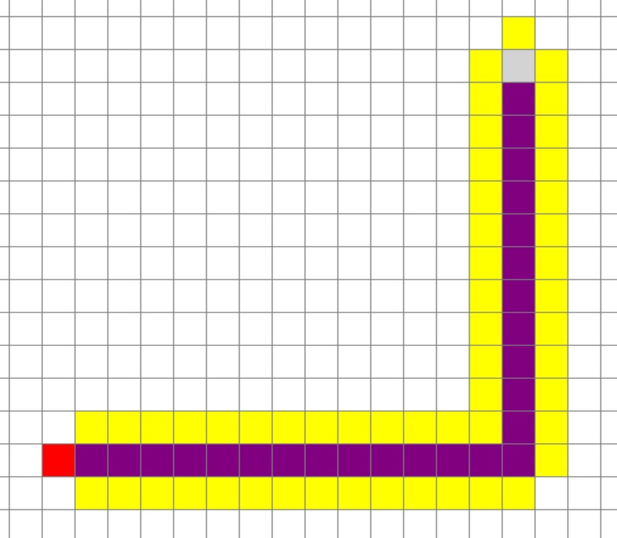
Worst Case Scenario
- Scenario: Dense obstacles, zig-zag path required.
- Expected Result: Algorithm explores many nodes before finding path.
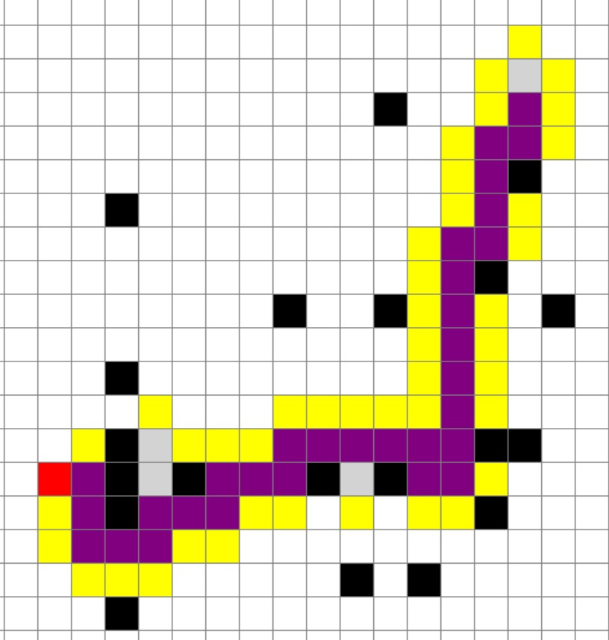
A*:
Best Case Scenario
- Scenario: Open grid, start and goal close, minimal obstacles.
- Expected Result: Algorithm finds path quickly with minimal node expansion.

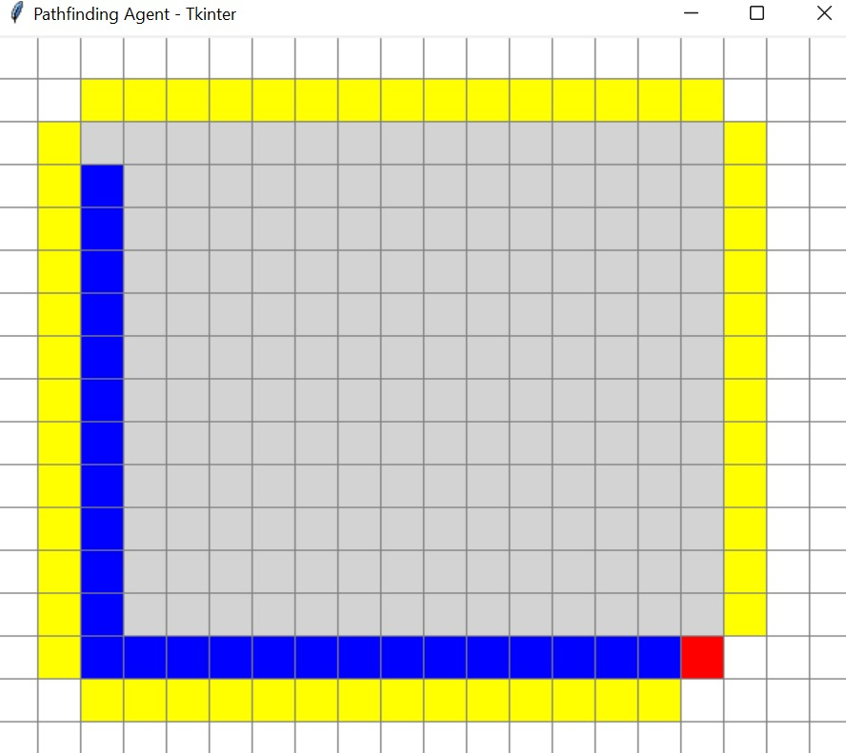
Worst Case Scenario
- Scenario: Dense obstacles, zig-zag path required.
- Expected Result: Algorithm explores many nodes before finding path.
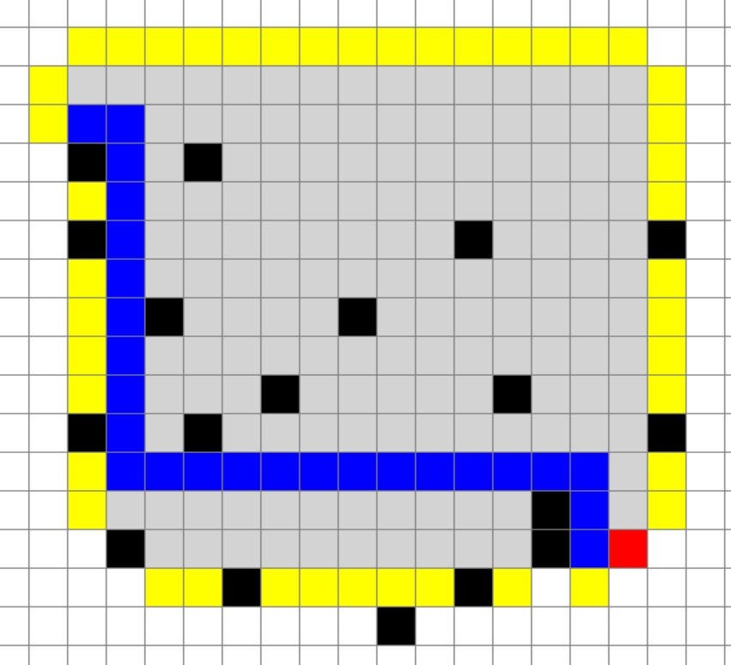
5. Conclusion
- Both A* and Greedy BFS effectively find paths in a grid-based environment.
- A* is optimal for shortest path but computationally heavier in complex grids.
- Greedy BFS is faster for simple cases but may fail to find optimal paths in cluttered grids.
- Visual GUI representation enhances understanding of pathfinding behavior.
GITHUB LINK:
GitHub

